COMPLAINT TRACKER

Project Report submitted for the partial fulfilment of grade for the course

DATA STRUCTURES AND ALGORITHMS - 3 (25CS2103E)

in
BACHELOR OF TECHNOLOGY

DEPARTMENT OF COMPUTER SCIENCE ENGINEERING

Submitted by

Y. Jahnavi – 2520030567
P. Devi sree – 2520030594
K. Shresta priya – 2520030127 Team Number: 11
Section: 9

Under the guidance of

Dr. S. Vinay Kumar
Associate Professor, Department of Computer Science and Engineering

A.Y. 2026–2027

Hyderabad-500090, Telangana, India.



DECLARATION
We hereby declare that the project report entitled “Complaint Tracker” is a record of bonafide work carried out by Y. Jahnavi – 2520030567, P. Devi sree – 2520030594, and K. Shresta priya – 2520030127 in partial fulfilment of the requirements for the course Data Structures and Algorithms - 3 (25CS2103E), during the academic year 2026–2027.
The work presented in this report is based on the development and study of efficient algorithms for managing and searching a corpus of customer complaint text documents. The report has been prepared for academic evaluation and has not been submitted elsewhere for the same purpose.
Y. Jahnavi – 2520030567
P. Devi sree – 2520030594
K. Shresta priya – 2520030127

CERTIFICATE
This is to certify that the project report entitled “Complaint Tracker” is a bonafide work carried out and submitted by Y. Jahnavi – 2520030567, P. Devi sree – 2520030594, and K. Shresta priya – 2520030127, in partial fulfilment of the requirements for the course Data Structures and Algorithms - 3 (25CS2103E), during the academic year 2026–2027, under the guidance of Dr. S. Vinay Kumar, Associate Professor, Department of Computer Science and Engineering.
The project demonstrates the practical application of Data Structures and Algorithms for efficient complaint searching, prioritization, assignment, and corpus processing.

Signature of the Guide

Dr. S. Vinay Kumar
Signature of the HOD

ACKNOWLEDGEMENT
We express our sincere gratitude to our guide, Dr. S. Vinay Kumar, Associate Professor, Department of Computer Science and Engineering, for his valuable guidance, encouragement, and suggestions throughout the development of our project, “Complaint Tracker.” His direction helped us understand how the concepts of Data Structures and Algorithms can be applied to a practical problem involving large collections of text documents.
We also thank the Department of Computer Science and Engineering and Koneru Lakshmaiah Education Foundation for providing the academic environment and resources required to complete this work. We are grateful to our faculty members and classmates for their support and feedback during the different stages of the project.
Finally, we thank our team members for their cooperation and contribution towards corpus preparation, algorithm implementation, testing, documentation, and presentation.
Y. Jahnavi – 2520030567
P. Devi sree – 2520030594
K. Shresta priya – 2520030127

ABSTRACT
The Complaint Tracker is a text-based system designed to efficiently manage and search large collections of customer complaints. The system organizes complaints using unique complaint IDs, categories, descriptions, statuses, priorities, and resolutions. A structured corpus containing multiple complaint records is used to demonstrate efficient pattern searching. The project implements string-matching algorithms such as Knuth-Morris-Pratt (KMP), Z-Algorithm, and Rabin-Karp with rolling hash to locate specific complaint patterns within the corpus. These algorithms reduce unnecessary comparisons and improve searching efficiency compared with simple brute-force searching, especially when processing large text datasets. Each complaint is maintained as an individual file and all records are combined into a single corpus for large-scale testing. The project also provides search results that identify matching complaint records and their IDs. Overall, the Complaint Tracker demonstrates the practical application of linear-time and efficient string-search techniques for organizing, retrieving, and analyzing complaint data.
Keywords: Complaint Tracker, Corpus, KMP, Z-Algorithm, Rabin-Karp, Pattern Searching, Data Structures and Algorithms.

TABLE OF CONTENTS

Chapter | Title | Contents
1 | Introduction | 1.1 Overview; 1.2 Problem  Statement; 1.3 Scope; 1.4 Objectives
2 | System Requirements | 2.1 Existing System; 2.2  Functional Requirements; 2.3 Non-Functional Requirements; 2.4 Hardware and Software
3 | System Design | 3.1 Architecture; 3.2 Corpus  Structure; 3.3 Algorithmic  Approach; 3.4 Workflow
4 | Implementation | 4.1 KMP; 4.2 Z-Algorithm;  4.3 Rabin-Karp; 4.4 Dynamic  Programming; 4.5 Network Flow; 4.6 Greedy Set Cover;  4.7 Randomized and Parallel Processing
5 | Results | 5.1 Testing; 5.2 Search  Results; 5.3 Algorithm  Complexity; 5.4 Analysis
6 | Challenges and Limitations | 6.1 Issues Faced; 6.2  Solutions Applied; 6.3 Limitations
7 | Conclusion and Future Work | 7.1 Conclusion; 7.2 Future Work; 7.3 Skills Learned
 | References | Books, papers, tutorials, and documentation

LIST OF FIGURES

Figure No. | Caption
3.1 | High-Level Architecture of Complaint Tracker
3.2 | Complaint Corpus Search Workflow
5.1 | Sample KMP Search Result

INTRODUCTION

Overview
Organizations receive customer complaints through different channels, and the resulting records can become difficult to search and organize when their number increases. The Complaint Tracker addresses this problem by maintaining complaint records as structured text documents and combining them into a corpus for algorithmic processing.
Each complaint contains information such as a unique complaint ID, category, description, status, priority, and resolution. The main focus of the project is efficient pattern searching over these complaint documents. Instead of checking every possible position using a simple brute-force method, the project studies efficient string-matching techniques that reduce unnecessary comparisons.
The project uses a corpus of complaint text files. A search pattern entered by the user is checked against the complaint files, and the system reports the files in which the pattern occurs. The project is designed as an application-oriented demonstration of Data Structures and Algorithms concepts.

Problem Statement
To develop a text-based Complaint Tracker that can efficiently search and manage a large corpus of customer complaint records using suitable Data Structures and Algorithms, thereby reducing unnecessary comparisons and improving the retrieval of relevant complaint records.

Scope of the Project
    - Maintain a corpus of individual customer complaint text files.
    - Search for a user-specified pattern or keyword across the complaint corpus.
    - Identify and report complaint files containing the requested pattern.
    - Demonstrate KMP, Z-Algorithm, and Rabin-Karp string matching techniques.
    - Apply additional algorithmic modules for prioritization, assignment, and efficient corpus processing.

    - Provide a basis for future integration with a graphical interface or database-backed complaint management system.

Objectives
- Create a structured corpus of complaint records for algorithmic testing.
- Implement efficient pattern-search techniques for complaint retrieval.
- Reduce unnecessary character comparisons compared with brute-force searching.
- Apply Data Structures and Algorithms concepts to complaint prioritization and assignment.
- Evaluate the algorithms using time-complexity analysis and corpus-based testing.
- Provide a simple and understandable system suitable for demonstrating practical DSA applications.

SYSTEM REQUIREMENTS

Existing System
In a manual or basic search approach, users may inspect complaint documents one by one or use direct substring comparison. Such methods become inconvenient when the corpus contains many documents and repeated searches are required.
The project therefore focuses on algorithmic methods that are designed to avoid unnecessary comparisons.

Functional Requirements
    - The system shall accept a search pattern from the user.
    - The system shall read complaint text files from the corpus directory.
    - The system shall search each complaint for the requested pattern.
    - The system shall display the names or IDs of matching complaint records.
    - The system shall report the total number of corpus files and matching files.
    - The system shall support algorithmic modules for complaint prioritization and assignment as part of the DSA demonstration.
    - The system shall provide clear output for successful and unsuccessful searches.

Non-Functional Requirements
    - Performance: Searching should avoid unnecessary character comparisons and use suitable time-efficient algorithms.
    - Usability: Console output should be simple and understandable for a student or evaluator.
    - Scalability: The corpus can be expanded by adding additional complaint text files.
    - Reliability: Invalid or missing corpus paths should be handled without terminating unexpectedly.
    - Maintainability: Each algorithm is kept as a separate Java module for easier testing and demonstration.

    - Portability: The implementation is designed to run in a standard Java environment.

Hardware and Software Requirements

Category | Requirement
Processor | Standard laptop/desktop processor
RAM | 4 GB or above recommended
Storage | Sufficient space for Java, source code, and corpus files
Operating System | Windows/Linux/macOS
Programming Language | Java
JDK | Java 8 compatible; compilation can use javac -  -release 8
IDE / Editor | VS Code or any Java-compatible IDE
Input Data | Complaint corpus containing text documents

SYSTEM DESIGN

High-Level Architecture
The system is organized into five logical layers: input, corpus storage, algorithm processing, result generation, and evaluation. The input layer receives a search pattern. The corpus layer stores individual complaint files. The algorithm layer applies the selected DSA technique. The result layer identifies matching complaint records and displays summary information. The evaluation layer is used to compare algorithmic behavior and complexity.



Figure 3.1 High-Level Architecture of Complaint Tracker

Complaint Corpus Structure
Each complaint is stored as an individual .txt file. The collection of these files forms the corpus used for large-scale testing. A typical record contains a complaint ID, category, description, status, priority, and resolution.

Field | Purpose | Example
Complaint ID | Unique identification of a complaint | C001
Category | Classifies the complaint | Billing
Description | Text describing the issue | Payment not reflected
Status | Current state of complaint | Open
Priority | Importance level | High

Resolution | Action taken or planned | Under verification

Algorithmic Approach
The primary search module uses string-matching algorithms. KMP preprocesses the pattern using the Longest Prefix Suffix (LPS) array. The Z-Algorithm constructs a Z-array to compare a pattern with text through prefix matching.
Rabin-Karp uses a rolling hash to compare candidate substrings efficiently. The project also maps other DSA concepts to complaint-processing tasks, including Dynamic Programming for prioritization, Network Flow for assignment, Greedy Set Cover for approximate resource selection, and randomized/parallel processing for scalable corpus operations.

Workflow

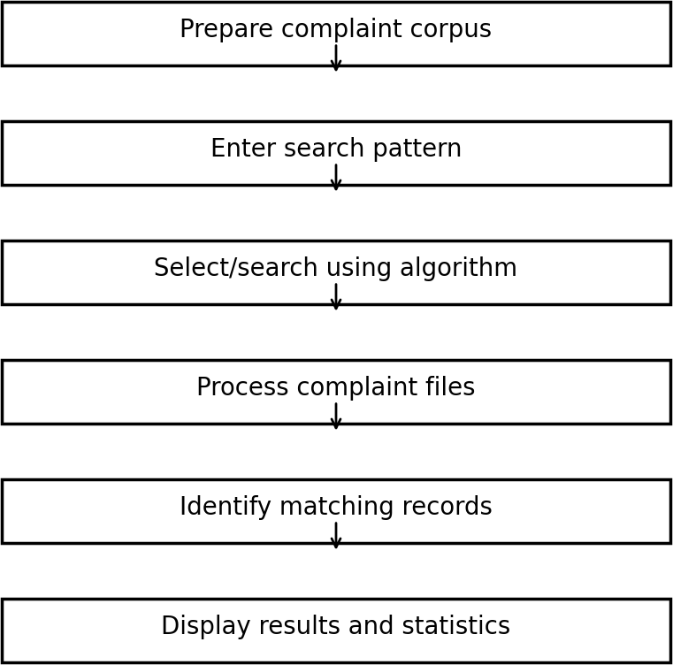

Figure 3.2 Complaint Corpus Search Workflow

IMPLEMENTATION

KMP Pattern Search
The Knuth-Morris-Pratt algorithm is the main demonstrated search algorithm. It preprocesses the search pattern and constructs an LPS array. During matching, when a mismatch occurs, the algorithm uses the LPS information instead of moving the text pointer backwards.
Pseudocode:
KMP_SEARCH(text, pattern)
- Build the LPS array for pattern.
- Set i = 0 and j = 0.
- While i is less than the length of text:
  - If text[i] equals pattern[j], increment i and j.
  - If j equals pattern length, report a match.
  - If mismatch and j is not zero, set j = LPS[j-1].
  - Otherwise increment i.
- Return no match if the scan finishes without a match.

Time complexity: O(n + m), where n is the text length and m is the pattern length.

Z-Algorithm
The Z-Algorithm can search for a pattern by constructing a combined string in the form pattern + separator + text and computing the Z-array. A position whose Z value equals the pattern length represents a complete pattern occurrence.
Pseudocode:
Z_SEARCH(text, pattern)
- Form S = pattern + '$' + text.
- Compute the Z-array for S.
- Scan the Z-array.
- Whenever Z[i] equals length(pattern), report a match.
- Return all matching positions.

Time complexity: O(n + m).

Rabin-Karp
Rabin-Karp uses a rolling hash. A hash value is calculated for the pattern and for each text window of the same length. When the hash values match, the characters are checked to confirm the match. Rolling the hash avoids recalculating the complete value for every window.
Pseudocode:
RABIN_KARP(text, pattern)
- Calculate the hash of the pattern.
- Calculate the hash of the first text window.
- Slide the window across the text.
- If the window hash equals the pattern hash, compare characters.
- Update the window hash using the rolling-hash formula.
- Report confirmed matches.

Average-case performance is efficient for pattern searching; the worst case can reach O(nm) when many hash collisions occur.

Dynamic Programming for Complaint Prioritization
A 0/1 Knapsack formulation can represent complaint prioritization when processing time is limited. Each complaint is treated as an item with a processing time and priority value. The DP table finds the maximum total priority that can be handled within the available time.
Pseudocode:
PRIORITIZE_COMPLAINTS(complaints, W)
- Create dp[i][w] for the first i complaints and time limit w.
- For each complaint i and each time w:
  - If its processing time is greater than w, copy dp[i-1][w].
  - Otherwise take the maximum of excluding or including complaint i.
- Backtrack from dp[n][W] to identify selected complaints.
- Return the selected complaints and maximum priority.
Time complexity: O(nW), where n is the number of complaints and W is the processing-time capacity.

Network Flow for Complaint Assignment
Complaint assignment can be represented as a flow network. A source is connected to complaint nodes, complaint nodes are connected to suitable departments, and department nodes are connected to a sink. Each capacity represents how many assignments are allowed through that edge. An Edmonds-Karp/Ford-Fulkerson approach repeatedly finds augmenting paths to maximize the number of feasible assignments.
Pseudocode:
MAX_FLOW(G, source, sink)
- Set all residual capacities.
- While an augmenting path exists from source to sink:
  - Find the path using BFS.
  - Find the minimum residual capacity on the path.
  - Update forward and reverse residual capacities.
  - Add the path capacity to total flow.
- Return total maximum flow.

Greedy Set Cover Approximation
A complaint-support planning problem can be represented as Set Cover. Required skills or support requirements form the universe, while teams form subsets covering some requirements. The greedy algorithm repeatedly selects the team covering the largest number of currently uncovered requirements. Since Set Cover is NP-hard, the greedy method provides an efficient approximation rather than an exact polynomial-time solution.
Pseudocode:
GREEDY_SET_COVER(U, sets)
- uncovered = U.
- selected = empty.
- While uncovered is not empty:
  - Select the set covering the largest number of uncovered elements.
  - Add the set to selected.

  - Remove its covered elements from uncovered.
- Return selected sets.

Randomized and Parallel Corpus Processing
Randomization can be used to select a sample of complaint records for testing, helping create different test subsets without manually choosing every file. Parallel processing can divide the corpus into independent groups and process multiple files concurrently. Because individual complaint files can usually be searched independently, the corpus provides a natural opportunity for parallel execution.
Pseudocode:
PARALLEL_CORPUS_SEARCH(files, pattern)
- Divide the corpus into independent file groups.
- Create worker tasks for the groups.
- Each worker searches its assigned files.
- Collect matching file IDs from all workers.
- Combine and display the final result.
The parallel design reduces wall-clock processing time when sufficient processor resources are available, although the actual speed-up depends on file size, storage speed, processor cores, and thread overhead.

RESULTS

Testing Strategy
The system is tested using a corpus of complaint text documents. Tests include patterns that occur in multiple files, patterns that occur in a single file, and patterns that do not occur. The output reports the searched pattern, the number of corpus files processed, and the number of matching files.

Sample KMP Search Result

Input | Observed Output
Search pattern | billing
Corpus files processed | 100 complaint text files
Matching records | Depends on the corpus contents
Algorithm | KMP
Time complexity | O(n + m)

Figure 5.1 represents the type of result displayed by the KMP module: the user enters a keyword, the corpus files are scanned, and matching complaint file names are displayed.

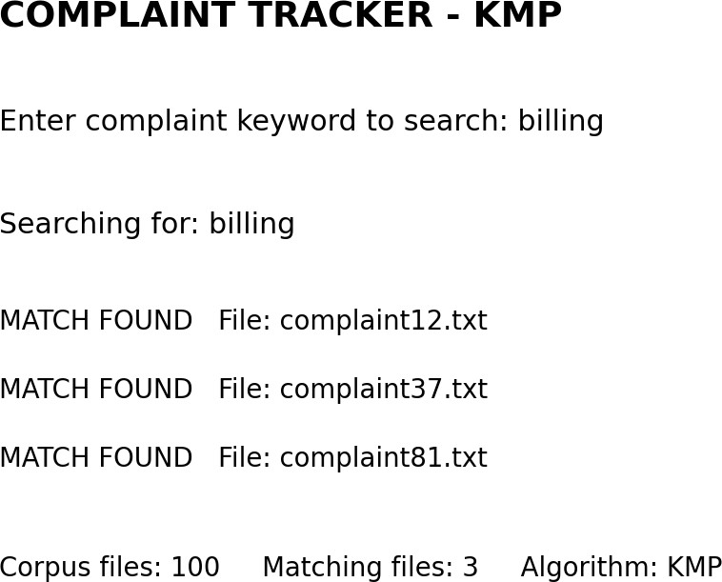

Figure 5.1 Sample KMP Search Result

Complexity Analysis

Algorithm / Module | Main Idea | Time Complexity
KMP | LPS-based pattern matching | O(n + m)
Z-Algorithm | Z-array prefix matching | O(n + m)
Rabin-Karp | Rolling hash | Average efficient; worst O(nm)
Dynamic Programming | 0/1 Knapsack prioritization | O(nW)
Network Flow | Augmenting-path maximum flow | Depends on graph and implementation
Greedy Set Cover | Choose largest newly covered set | Polynomial per greedy iteration
Parallel Corpus Search | Independent file processing | Depends on workers and workload

Analysis
The main benefit of the project is the use of algorithmic techniques instead of treating complaint search as a simple repeated character comparison task. KMP provides predictable linear-time pattern searching after preprocessing. Z-Algorithm provides another linear-time string-search approach, while Rabin-Karp demonstrates hashing and rolling-window processing. The additional modules show how different DSA concepts can be mapped to practical complaint-processing tasks.
The corpus-based design also makes the project scalable for academic testing because new complaint files can be added without changing the overall search workflow.

CHALLENGES AND LIMITATIONS

Issues Faced During Development
    - Handling a large number of individual complaint text files while keeping the folder structure simple.
    - Ensuring the Java implementation remains compatible with the available Java environment.
    - Understanding and implementing string-matching algorithms correctly, especially pattern preprocessing.
    - Mapping theoretical DSA concepts such as flow and Set Cover to a complaint-management scenario.
    - Testing search behavior for patterns that are present, absent, or repeated across multiple files.

Solutions Applied
    - The corpus was organized as separate .txt complaint records in a dedicated folder.
    - The Java code uses Java 8-compatible file reading methods so that it can run in the available environment.
    - KMP uses the LPS array to avoid unnecessary comparisons after mismatches.
    - Independent algorithm modules were created so each DSA concept can be demonstrated separately.
    - Test cases were designed around different search patterns and corpus conditions.

Limitations of the System
    - The current system is text-based and does not provide a full graphical user interface.
    - Complaint records are maintained as text files rather than a production database.

    - The search module focuses on exact pattern matching and does not perform semantic or natural-language understanding.
    - Algorithm demonstrations for prioritization and assignment use simplified models compared with a real organization's workflow.
    - Parallel performance depends on hardware resources and the size of the corpus.

CONCLUSION AND FUTURE WORK

Conclusion
The Complaint Tracker demonstrates how Data Structures and Algorithms can be applied to a practical text-processing problem. A corpus of complaint records provides a realistic environment for testing efficient pattern-search techniques.
KMP, Z-Algorithm, and Rabin-Karp illustrate different approaches to locating patterns in large text collections, while additional algorithmic modules demonstrate prioritization, assignment, approximate resource selection, and scalable corpus processing.
The project provides a clear foundation for efficient complaint retrieval and shows the importance of selecting suitable algorithms based on the nature of the problem. The modular design also makes it possible to extend the system with additional functionality in future work.

Future Work
    - Add a graphical or web-based user interface for complaint entry and search.
    - Store complaint records in a database and provide persistent status tracking.
    - Integrate all string-search algorithms into a single user-selectable search module.
    - Add semantic search and text classification for category and priority prediction.
    - Provide authentication and role-based access for complaint handlers.
    - Use larger real-world datasets and benchmark execution time across algorithms.
    - Improve parallel processing using configurable worker counts and workload balancing.

Skills Learned During Development
    - Application of string-matching algorithms to real text data.
    - Pattern preprocessing and complexity analysis.
    - Dynamic Programming formulation and table-based optimization.

    - Graph modeling and maximum-flow reasoning.
    - Greedy approximation for an NP-hard problem.
    - File handling, corpus organization, testing, and Java implementation.
    - Technical documentation, presentation, and algorithm-based problem solving.

REFERENCES
- T. H. Cormen, C. E. Leiserson, R. L. Rivest, and C. Stein, Introduction to Algorithms, MIT Press.
- D. E. Knuth, J. H. Morris, and V. R. Pratt, “Fast pattern matching in strings,” SIAM Journal on Computing.
- R. Sedgewick and K. Wayne, Algorithms, Addison-Wesley.
- Java Platform documentation, Oracle, Java SE documentation.
- Project abstract, “Complaint Tracker,” Data Structures and Algorithms - 3 (25CS2103E), A.Y. 2026–2027.
- Course project document guidelines, Department of Computer Science Engineering, 2026–27.

